**Proceedings of the GTEA Seminar Guidelines for Manuscript Preparation**

Author Name1,a, Author Name2,b, *, Author Name3,c

1First Author’s English Affiliation

2Second Author’s English Affiliation

3Third Author’s English Affiliation

aEmail, bEmail, cEmail

This sample document provides the authors with information and instructions to prepare camera-ready submission to The GTEA Conference. Accepted papers will be published in conference proceedings with full version in Electronic and hard copy. Failure to follow this format may result in a submission being rejected for publication.. The length of each paper should not exceed **2 pages**. Manuscripts submitted should strictly follow the format of this template. Only manuscripts in the PDF format **with no page numbers** are acceptable and manuscripts should be submitted via the official website of the GTEA, The size of the PDF file should be less than **3 MB**.. **【Font Setting】**The acceptable fonts are Times New Roman and Symbol. The title of the article should be in 14-point boldface type. Capitalize the first letter of nouns, pronouns, verbs, adjectives, and adverbs; do not capitalize articles, coordinate conjunctions, or prepositions (unless the title begins with such a word). Authors’ names and affiliations are to be centered beneath the title and in 12-point non-boldface type. Subtitles should be in 12-point and boldface. Type your main text in 10-point. All paragraphs should be indented by 0.9 cm. **【Margin Setting】**The paper size is A4 (21 cm by 29.7 cm) with the following margins: upper 3 cm, lower 3 cm, left 2 cm, and right 2 cm. **These margin settings should be followed under all circumstances**. **【Figures and Tables】**Figures and tables can be either placed at the end of paper as demonstrated in this template, or inserted within the running text. Captions of figures and tables should be in 10-point Times New Roman. The alignment of the caption can be either centered or justified, depending on the width of the figure. **【Equations】**Equations should be centered aligned and numbered.

 (1)

Keywords:A list of 1-4 keywords should be included right beneath the abstract.

**Acknowledgements**

This work is funded by National Science Council under grant MOST-000-0000-E-000-MY3.

**References**

1. A.B. Author, Title of Book, ABC Press, Taichung, Taiwan, pp. 300-307, 2005.
2. C.D. Author, “Title of Article,” Journal, Vol. 06, pp. 1-20, June 2006.
3. E.F. Author, and G.H Author, “Title of Paper,” Proc. of 1st ILT Conference, Taichung, Taiwan, pp. 500-507, June 2006.

**Figures and Tables**

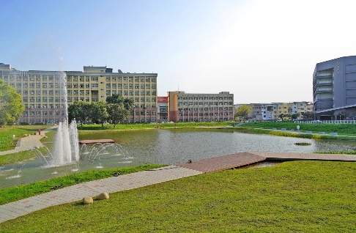

**Table 1. Table captions**

|  |  |  |  |
| --- | --- | --- | --- |
| Margins (cm) | | | |
| top | bottom | left | right |
| 3 | 3 | 2 | 2 |

**Fig1. Organizer**